Day wise report for a given month for all employees or employees per department:

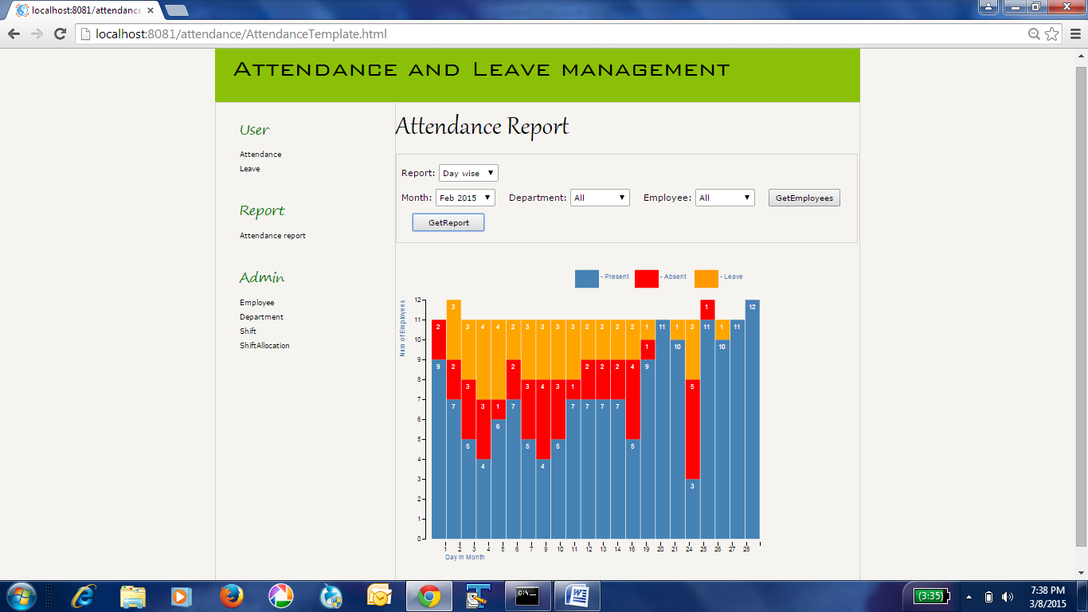

Monthly Report : Provides number of occurrences of presence, absence and leave for all employees or employees per department

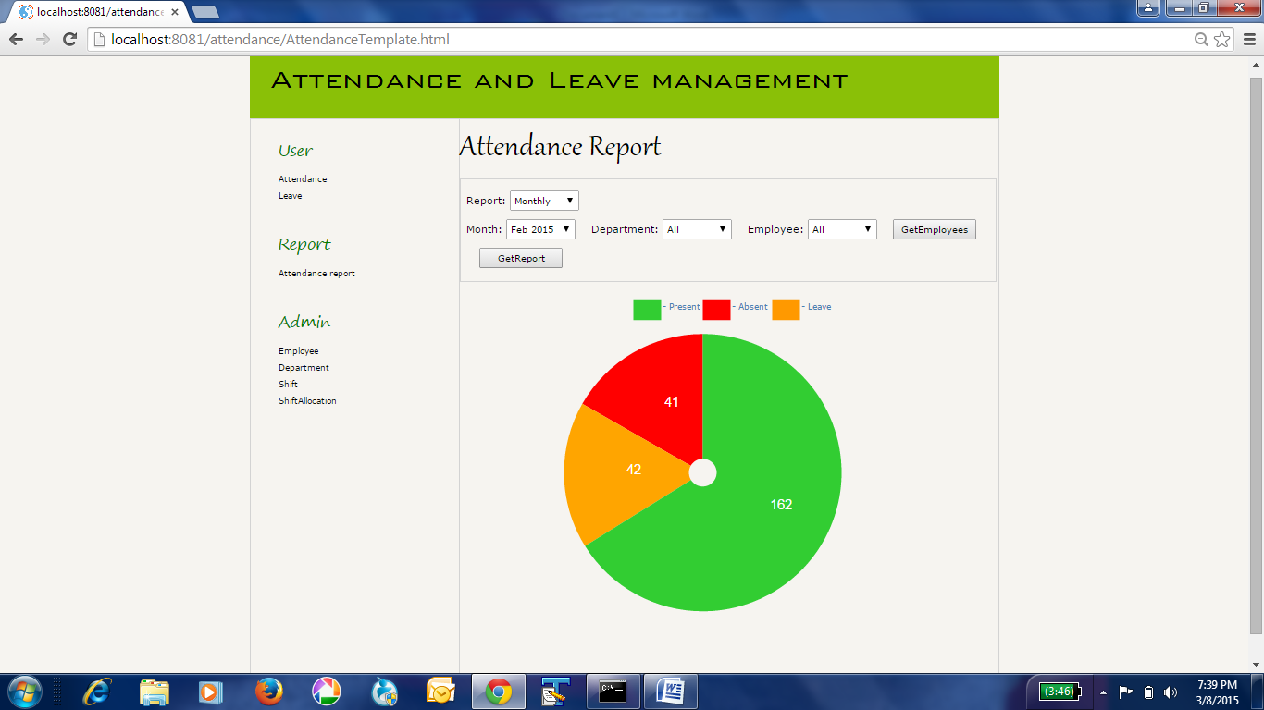

Day wise report for a particular employee. This provides a calendar like structure and color codes the presence, absence and leave of the chosen employee.

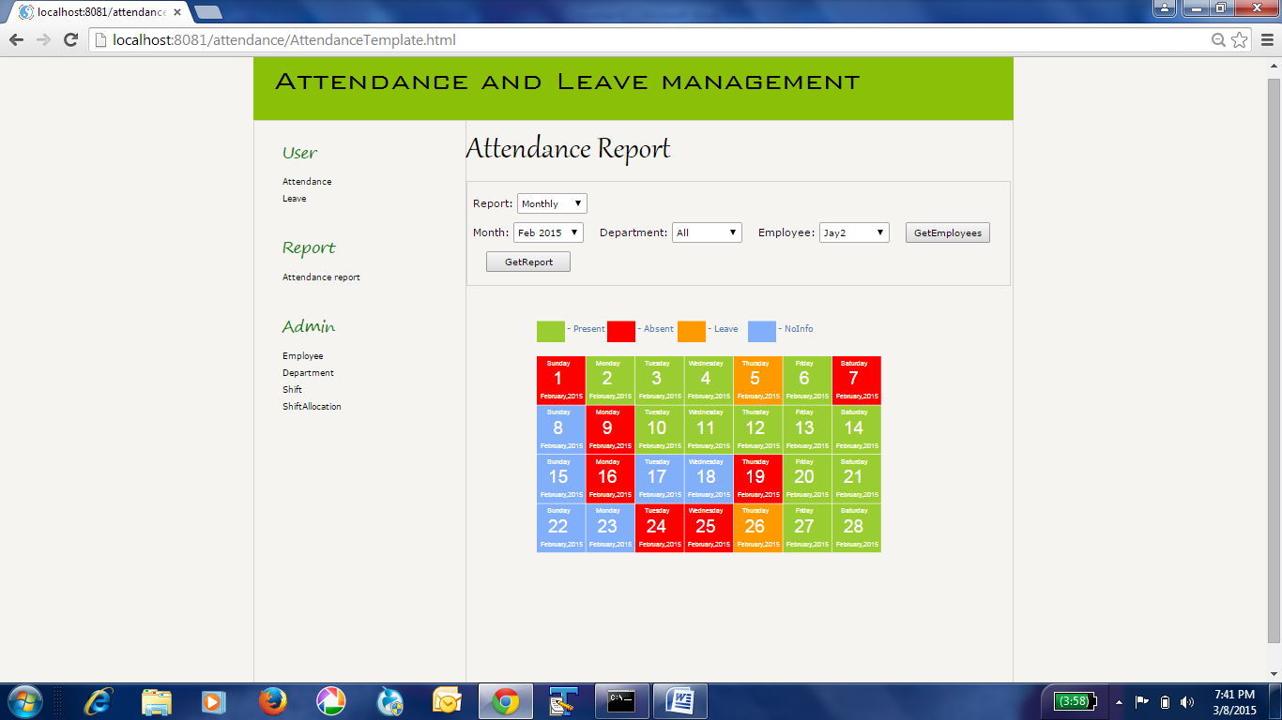

Bibliography:

1. HTML5 - W3C schools - www.w3schools.com/

2. CSS - W3C school - www.w3schools.com/

2. D3JS - D3JS home page - http://d3js.org/ and D3JS Tutorials on you tube.

3. Java script - Node school - http://nodeschool.io/, Architect Douglas crockford's web log - http://javascript.crockford.com/ , Java script tutorial videos on You tube and Stack overflow http://stackoverflow.com/

4. Node JS - Book - Node Beginner by Manuel Kiessling. - Node school - http://nodeschool.io/.

5. Postgresql - http://www.postgresql.org/ and stack overflow - http://stackoverflow.com/